Nios II project

Start “Nios II 16.0 Software Build Tools for Eclipse”, choose Workspace folder :

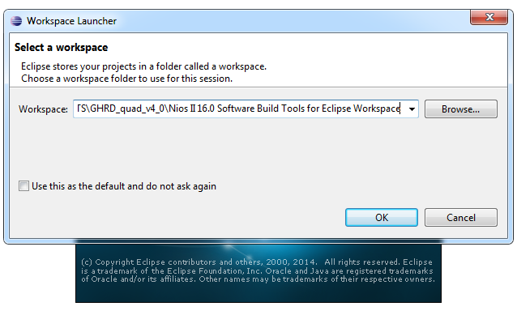

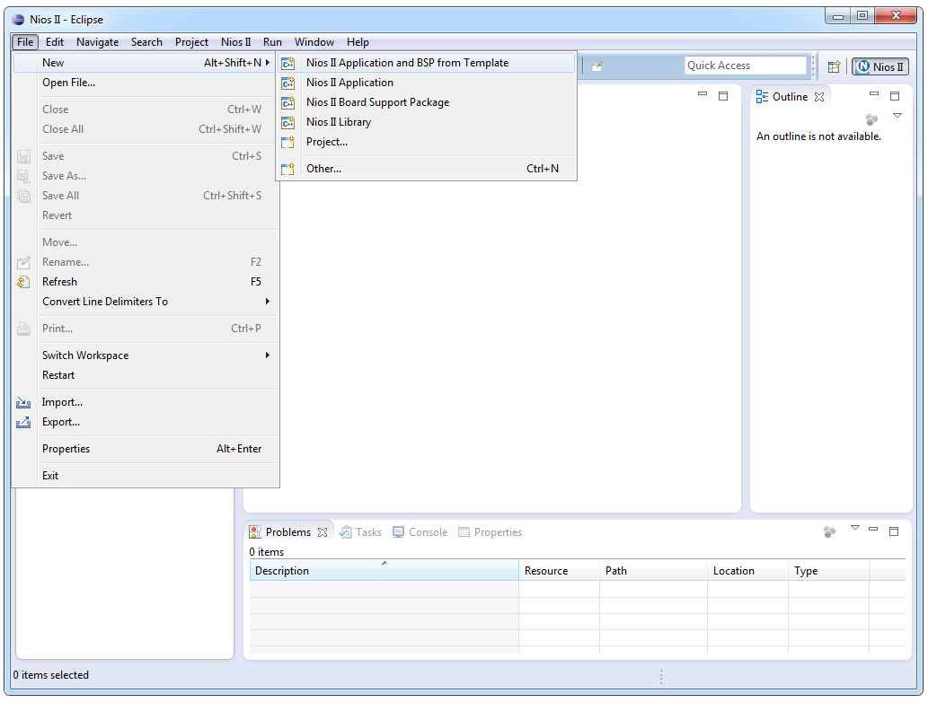

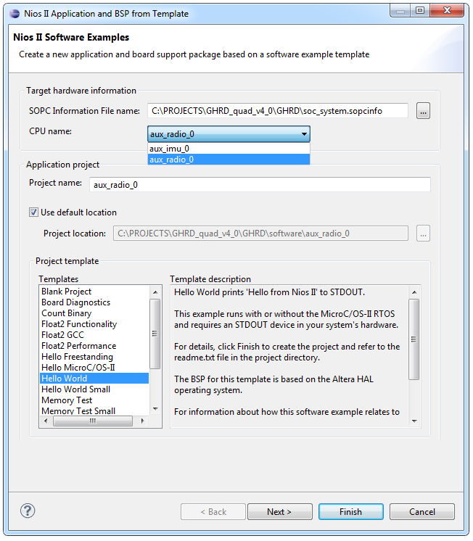

Choose .sopcinfo file, select processor, provide project name